|  |  |  |  |  |  |  |  |
| --- | --- | --- | --- | --- | --- | --- | --- |
|  | **April 2012** | | | | | | |
| veke | Mandag | Tirsdag | Onsdag | Torsdag | Fredag | Lørdag | Søndag |
| 13 |  |  |  |  |  |  | 1 |
| 14 | 2 | 3 | 4 | 5 | 6 | 7 | 8 |
| 15 | 9 | **10** | **11** | **12** | **13** | **14** | **15** |
| 16 | **16** | **17** | **18** | **19** | **20** | **21** | **22** |
| 17 | **23** | **24** | **25** | **26** | **27** | **28** | **29** |
| 18 | **30** |  |  |  |  |  |  |

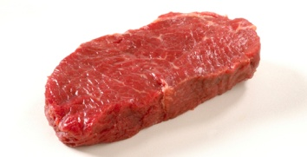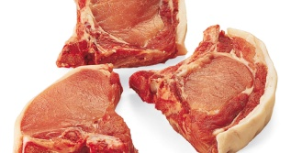

|  |  |  |  |  |  |  |  |
| --- | --- | --- | --- | --- | --- | --- | --- |
|  | **Mai 2012** | | | | | | |
| Veke | Mandag | Tirsdag | Onsdag | Torsdag | Fredag | Lørdag | Søndag |
| 18 |  | **1** | **2** | **3** | **4** | **5** | **6** |
| 19 | **7** | **8** | **9** | 10 | 11 | 12 | 13 |
| 20 | 14 | 15 | 16 | 17 | 18 | 19 | 20 |
| 21 | 21 | 22 | 23 | 24 | 25 | 26 | 27 |
| 22 | 28 | 29 | 30 | 31 |  |  |  |

